Welcome to Leicester.
- Cafés / food:
  - Bossa café on Granby Street. They do really good coffee and serve yummy food from 11am Wed-Fri.
  - The Exchange café and bar. Delicious food and relaxed atmosphere. They serve breakfast from £1 on weekdays (Wednesday is free breakfast!). On Mondays they do a coin toss for free pizza. They have pub quizzes on Tuesday nights, and free comedy nights. www.exchangeleicester.com
Open 9am – late on Mon-Friday,
10am til late on Saturday, noon til late on Sunday.
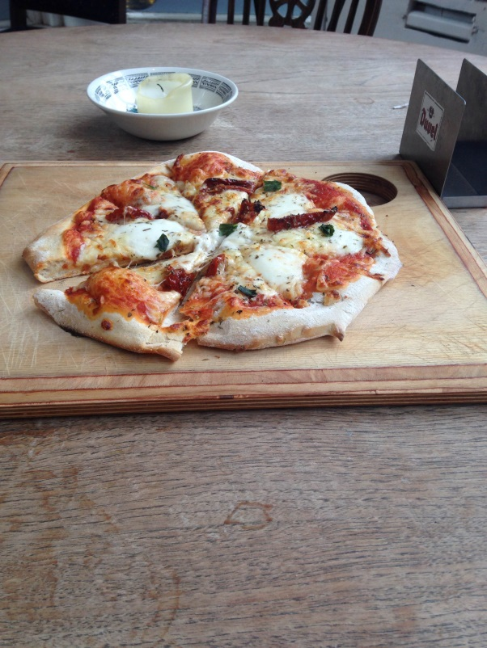
  - Curry. There are lots of places. I liked Satkar for deliveries but it’s vegetarian.
  - Shivalli – Indian offering 3 courses for £10.
  - Costa – the best coffee
- Fitness:
  - ‘the gym’ does affordable no contract monthly membership. It is 24/7 and is in the centre of town near Highcross. www.thegymgroup.com
  - Bootcamps are available around Leicester and can be quite affordable especially if you find a voucher deal: www.groupon.co.uk
- Salsa classes –
  - www.havana-salsa.co.uk
  - The classes at Abbey Park Sports and Leisure Centre are great. There is a good mix of young people as well and the instructors are very good. You can sometimes find a groupon.co.uk deal for £12 for 8 classes… otherwise it is £6 per class (each class is an hour long), or £32 for an 8 week course.

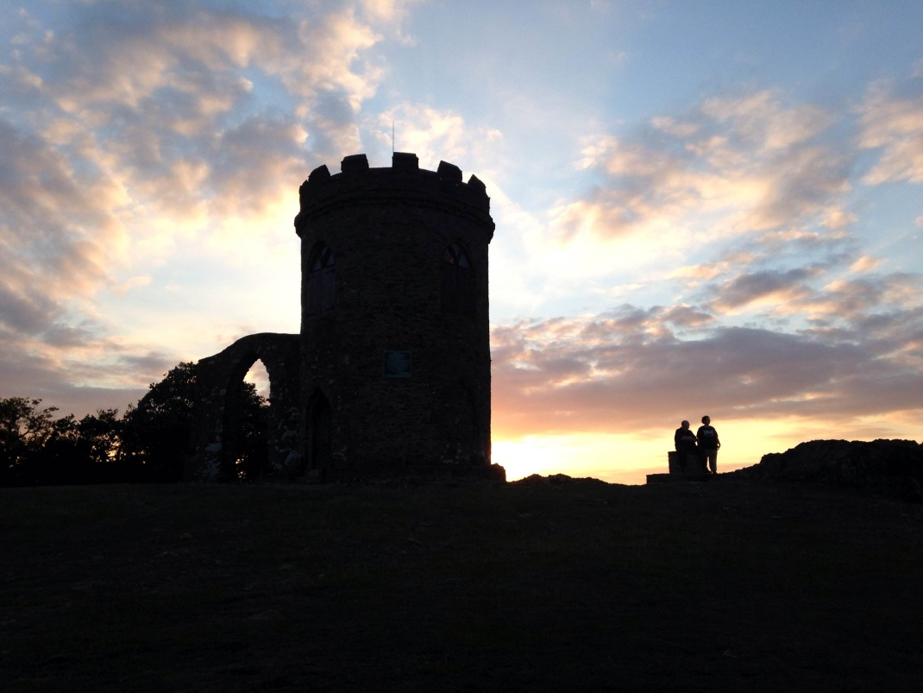
- Outdoors:
  - Go to Bradgate Park (above) on a nice evening or a sunny day. It is beautiful! There are deer. You can also run/walk to the top of the hill for a bit of a view and exercise.
  - Victoria Park seems like a good place to go for a run. Abbey Park is alright as well during the day.
- Museums: Newwalk museum is free but it’s not very big, and definitely not a must see. Just something to do if you are bored and in the vicinity.
- Theatres:
  - The main theatre is ‘The Curve’. There are good shows on here from a variety of different theatre companies and tickets are often affordable. It is just across the road from The Exchange bar. www.curvetheatre.co.uk. They sometimes do discounts on the day, otherwise tickets are slightly cheaper for 18-25 year olds.
  - Phoenix theatre (just around the corner from The Curve) has interesting films ranging from foreign films to silent movies; all very thought provoking. www.phoenix.org.uk
  - There are other theatres that I didn’t get a chance to go to:
    - www.littletheatre.net (smaller professional productions)
    - www.demontforthall.co.uk (larger scale shows and concerts)
    - www.leicesterymca.co.uk/y-theatre.php (small semi-amateur shows)
    - www.upstairsatthewestern.com (local professional productions – stand-up comedy, spoken word etc.)
- Nightlife:
  - There are pubs and bars around Highcross within walking distance of each other. Most have entry fees.
- Getting around: Google maps is best for bus and cycle routes.
  - There is a bicycle! It has gears that work, a helmet and a lock!!!. I recommend sticking to the cycle routes as much as possible..
  - Buses: there are about 13 different bus companies which all have different systems and fares (it’s a nightmare). Most buses charge £1.40 - £2.70. Centrebus notoriously runs late but all the other buses from outside Arnold Lodge (Arriva) run roughly on time. I still don’t understand the options for weekly travel cards because there are too many different bus companies. The flexi day £5 covers all buses and unlimited trips for a day. Flexi weekly £19 includes all buses and umlimited trips for a week. UHL-hospital hopper smartcard £16 to buy and 10 trips. Buy at car park at hospital.
  - Walking: from Leicester General Hospital it takes about 30 minutes but in the cold it feels much shorter.
  - Trains – railcard £30 – you need passport and passport sized photo. Can buy at any national rail station, including Leicester.
  - Coaches – young person’s coachcard for 18-26 year olds on National Express.
- Shopping
  - Closest big Tesco is Tesco Extra Hamilton – also used by patients on leave from the hospital.
  - Highcross – the best shopping
- Leaving Leicester:
  - The train to London St. Pancras Intl. takes around 1 ½ hours. If you book tickets in advance and catch early trains then it cost around £15-25. Book with www.thetrainline.com or www.eastmidlandstrains.co.uk .
  - Ryanair do cheap flights to the rest of Europe and you can fly out from either Luton Airport (1 hr by train towards London, or 1½ hours on National Express and much cheaper)) or East Midlands Airport (?1hr by bus). http://www.ryanair.com/en/cheap-flights/?from=STN
- Things to do in London
  - Big Ben
  - Borough Market
  - Free walking tour
  - Camden Lock Market
  - Covent Garden
  - Madame Tussauds
  - London Eye
  - Buckingham Palace
  - Hampton Court Palace
  - Harry Potter Tour

Please edit/add/update after your stay in Leicester
Enjoy!
From,
- Emily (New Zealand Medical Student), Lora (Australia), Anna (Hungary)

